**EXPERIMENT NO 10**

**Rushikesh Tanksale**

**221078**

**COMP A**

Aim :- Implement MYSQL database connectivity with Java for Database navigation operations such as insert, delete, update etc. using ODBC/JDBC.

1. **Prerequisites (Download And Install Following)**
2. JDK(Latest Version)
3. MYSQL (Also Download MYSQL Workbench For GUI)

**(**After Installing MYSQL keep password as **‘root’** same as username forsaving time while executing the following)

1. MYSQL JDBC DRIVER (“MYSQL Connector/J”) Extract the zip file in same folder as workspace of eclipse
2. **Create a database in MYSQL**

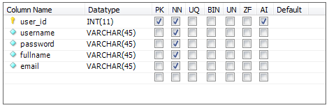

This is the schema of database (Created using workbench)

**Other way is running following query in mysql terminal**

create database SampleDB;

use SampleDB;

CREATE TABLE `users` (`user_id` int(11) NOT NULL AUTO_INCREMENT,`username` varchar(45) NOT NULL,`password` varchar(45) NOT NULL,`fullname` varchar(45) NOT NULL,`email` varchar(45) NOT NULL, PRIMARY KEY (`user_id`));

1. **Creating the Java Project**

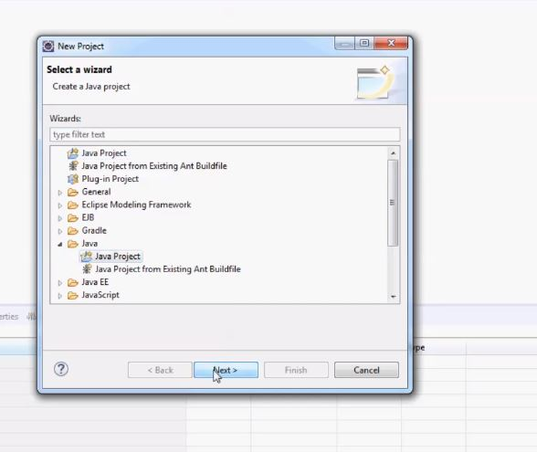

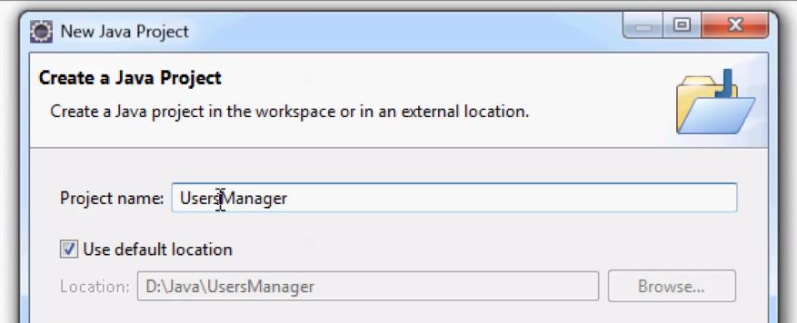

* 1. **Creating New Java Package**

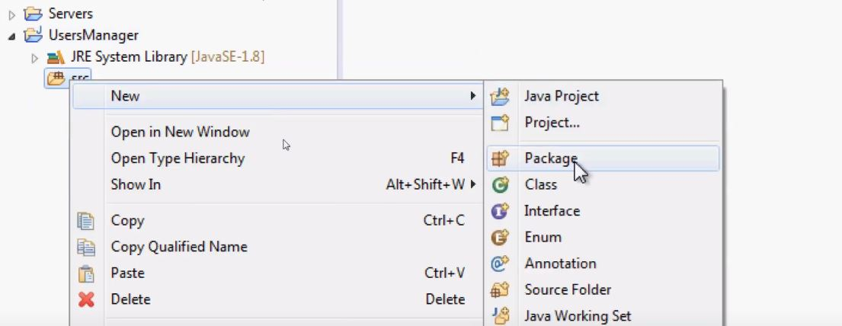

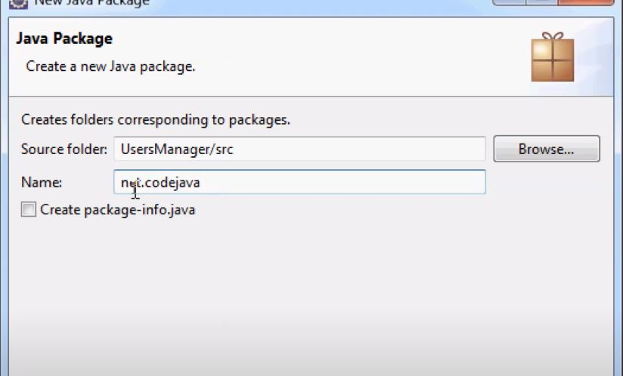

**Give name net.codejava**

* 1. **Creating New Class**

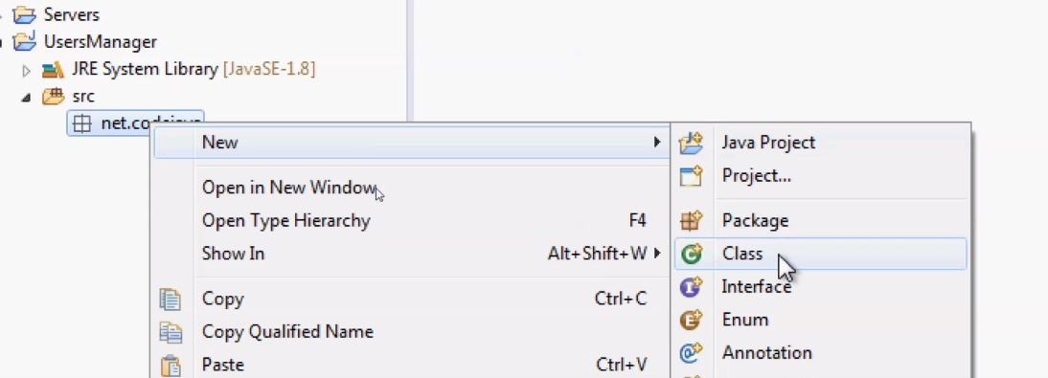

**Right Click on net.code java**

**Then create new class**

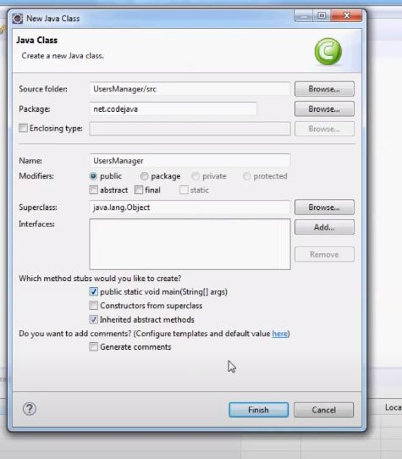

String dbURL = "jdbc:mysql://localhost:3306/sampledb";

String username = "root"; “**Enter your database username”**

String password = "root"; “**Enter your database password”**

try {

Connection conn = DriverManager.getConnection(dbURL, username, password);

if (conn != null) {

System.out.println("Connected");

}

} catch (SQLException ex) {

ex.printStackTrace();

}

**Run the following code if it gets executed and you see “Connected” in console you can skip the J Connector Part If You Get exceptions the do the following steps**

* 1. **Enabling Connector/J**

1. Go to <https://dev.mysql.com/downloads/>

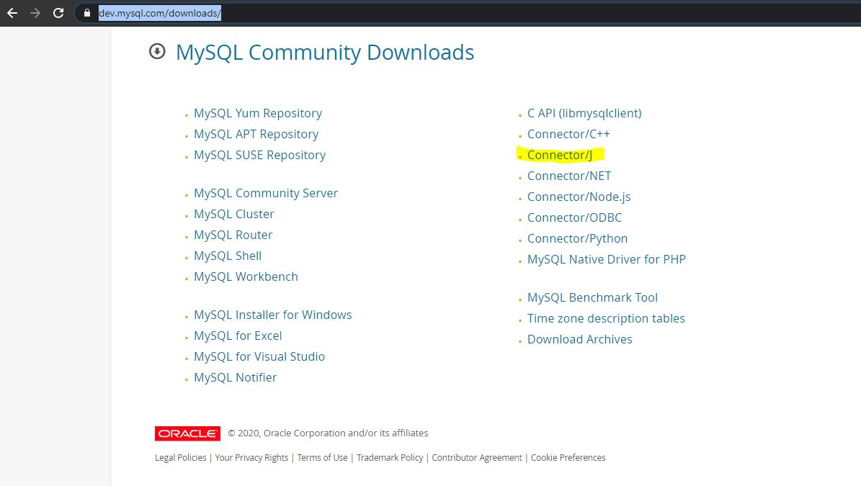

Download Connector/J

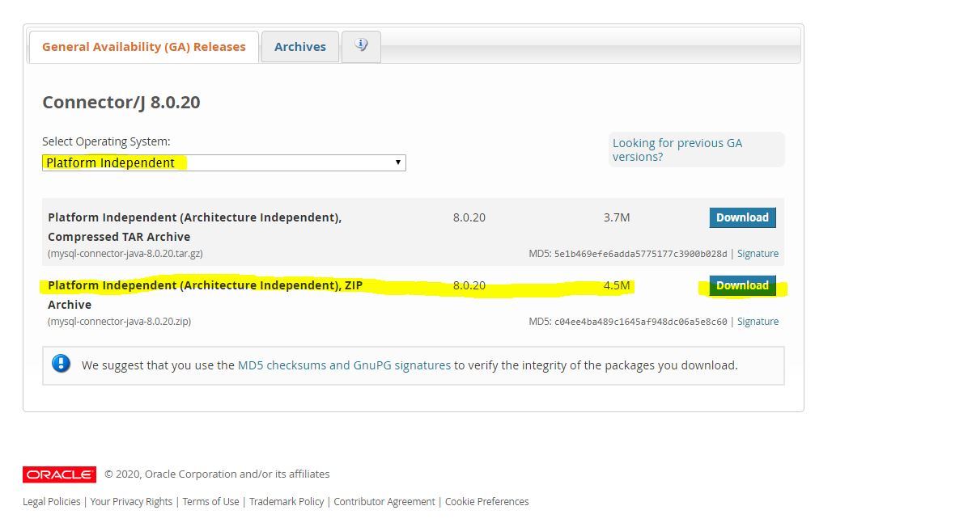

Download it as platform independent (Download Highlighted One)

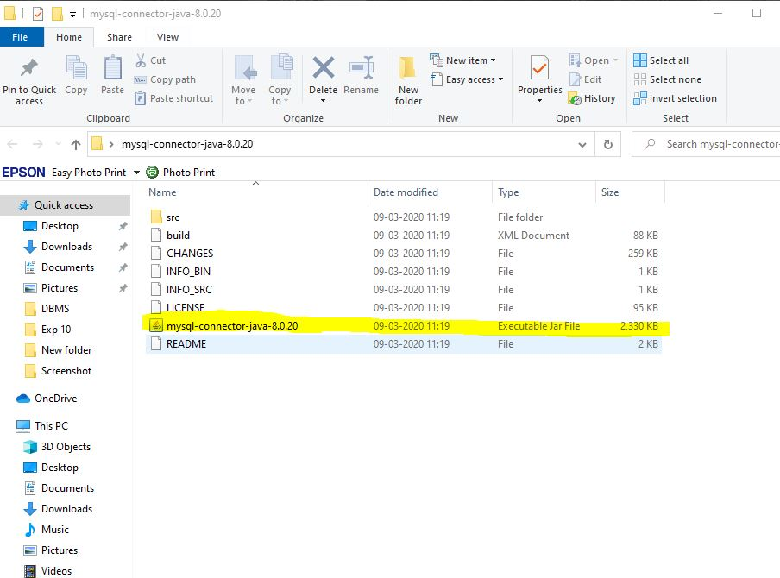

**Extract the zip file**

**Step 4 enabling the connectivity in eclipse**

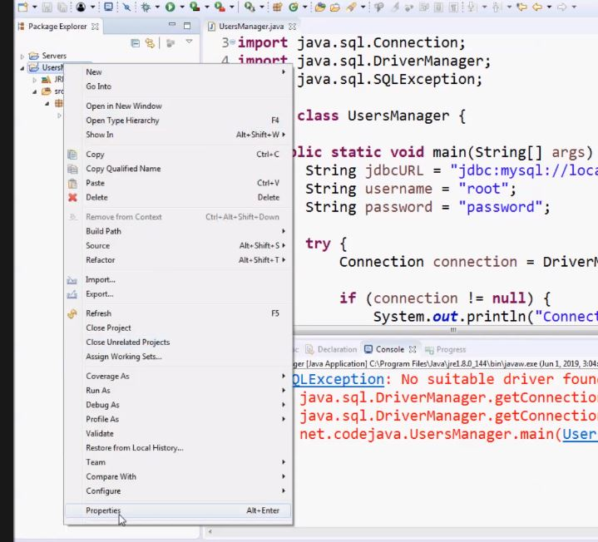

Right Click on project and go in its properties

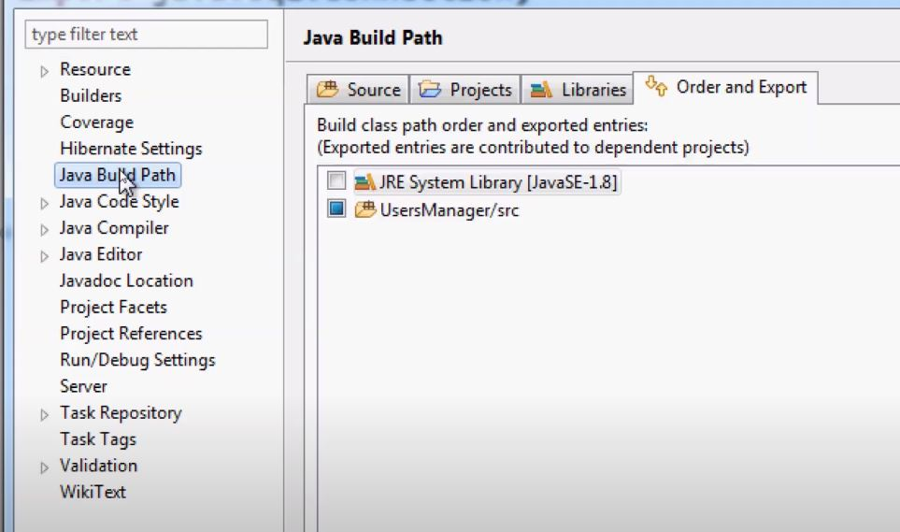

Select Build Path and go in libraries

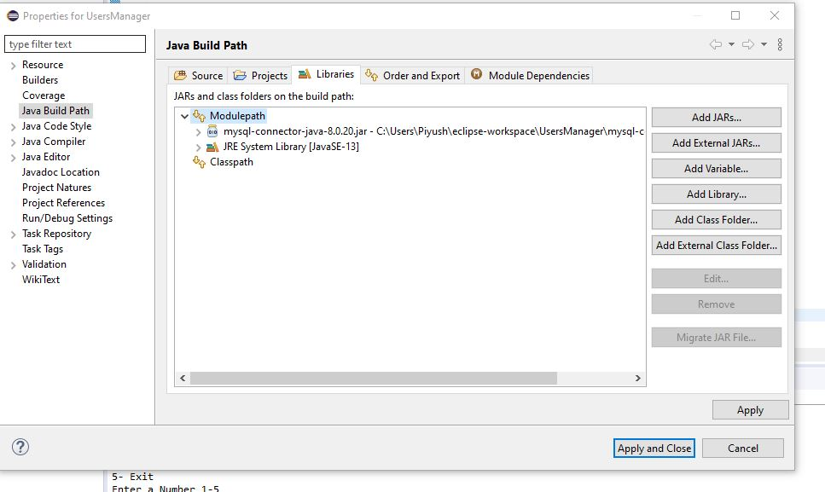

Click on add external jars (Click on module path then the option can be accessed)

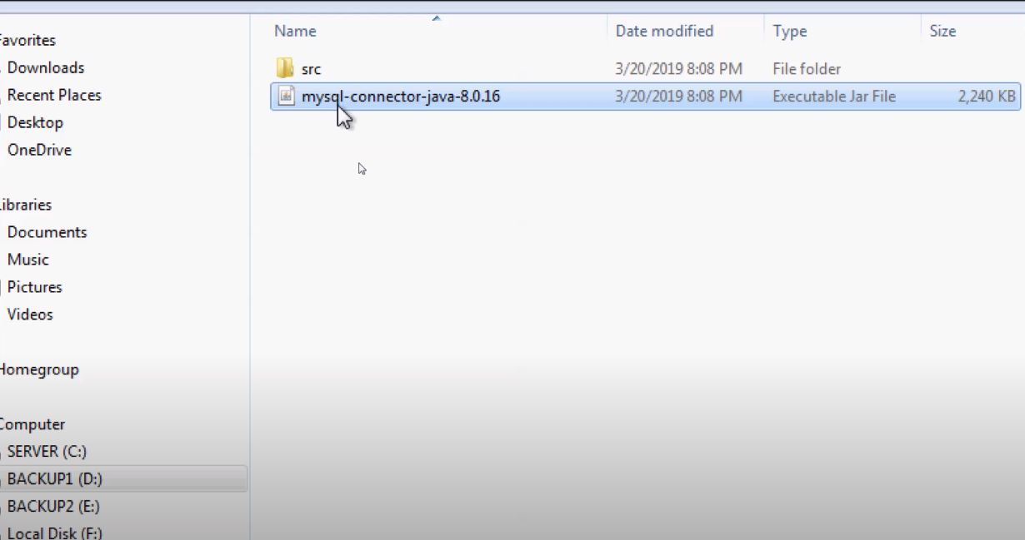

Navigate the jar file extracted and click ok

**Now try to run the following code**

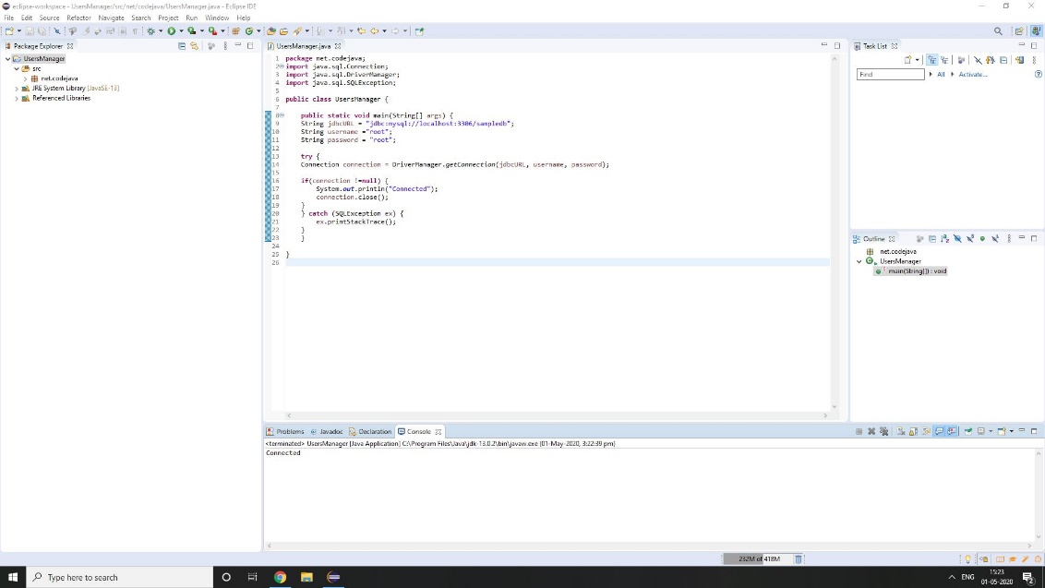

**You will get connected which means you are connected to DB**

**Then Try one by one as of CRUD Properties**

1. **CREATE (INSERT IN SQL)**

String sql = "INSERT INTO Users (username, password, fullname, email) VALUES (?, ?, ?, ?)";

PreparedStatement statement = conn.prepareStatement(sql);

statement.setString(1, "bill");

statement.setString(2, "secretpass");

statement.setString(3, "Bill Gates");

statement.setString(4, "bill.gates@microsoft.com");

int rowsInserted = statement.executeUpdate();

if (rowsInserted > 0) {

System.out.println("A new user was inserted successfully!");

}

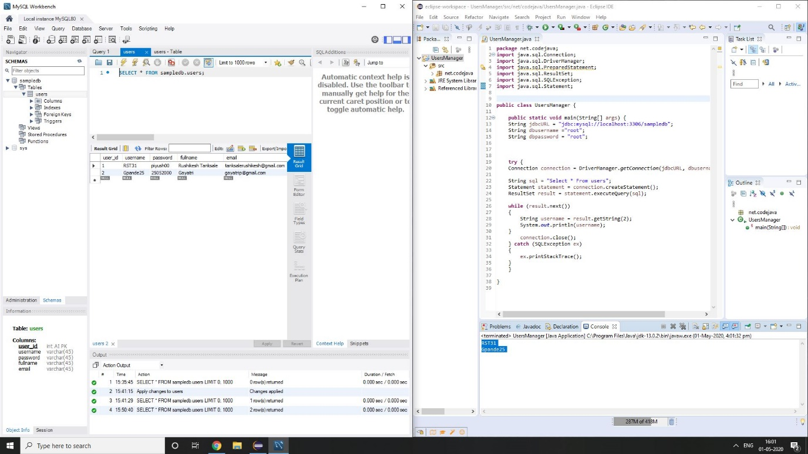

1. **Retrieve (Select Statement in SQL)**

String sql = "SELECT * FROM Users";

Statement statement = conn.createStatement();

ResultSet result = statement.executeQuery(sql);

int count = 0;

while (result.next()){

String name = result.getString(2);

String pass = result.getString(3);

String fullname = result.getString("fullname");

String email = result.getString("email");

String output = "User #%d: %s - %s - %s - %s";

System.out.println(String.format(output, ++count, name, pass, fullname, email));

}

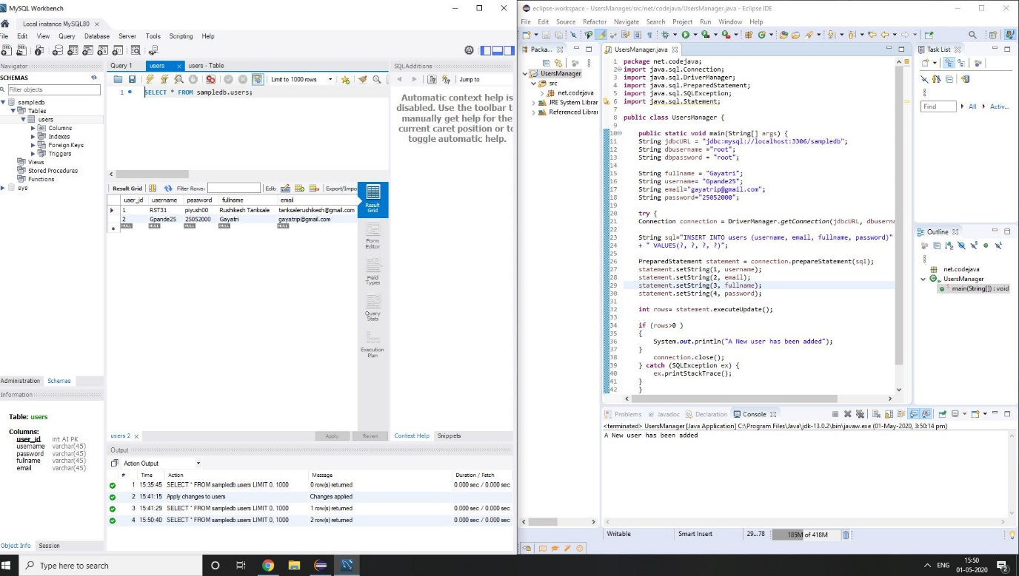

**6. Update (Update As SQL)**

String sql = "UPDATE Users SET password=?, fullname=?, email=? WHERE username=?";

PreparedStatement statement = conn.prepareStatement(sql);

statement.setString(1, "123456789");

statement.setString(2, "William Henry Bill Gates");

statement.setString(3, "bill.gates@microsoft.com");

statement.setString(4, "bill");

int rowsUpdated = statement.executeUpdate();

if (rowsUpdated > 0) {

System.out.println("An existing user was updated successfully!");

}

**7. Delete (Delete / Truncate)**

String sql = "DELETE FROM Users WHERE username=?";

PreparedStatement statement = conn.prepareStatement(sql);

statement.setString(1, "bill");

int rowsDeleted = statement.executeUpdate();

if (rowsDeleted > 0) {

System.out.println("A user was deleted successfully!");

}

Following Is the Java Code I Made for Menu Driven CRUD Operations

Just update database username and password and and database name along with table name if needed

**package** net.codejava;

**import** java.sql.Connection;

**import** java.sql.DriverManager;

**import** java.sql.PreparedStatement;

**import** java.sql.ResultSet;

**import** java.sql.SQLException;

**import** java.sql.Statement;

**import** java.util.Scanner;

**public** **class** UsersManager {

**public** **static** **void** main(String[] args) {

String jdbcURL = "jdbc:mysql://localhost:3306/sampledb";

String dbusername ="root";

String dbpassword = "root";

**int** i=0;

Scanner sc = **new** Scanner(System.***in***);

System.***out***.println("Java MYSQL CRUD OPERATIONS");

System.***out***.println("1- Print Records From Table");

System.***out***.println("2- Add Record To The Table");

System.***out***.println("3- Update Table");

System.***out***.println("4- Delete");

System.***out***.println("5- Exit");

System.***out***.println("Enter a Number 1-5");

i=sc.nextInt();

sc.nextLine();

String s;

**try** {

Connection connection = DriverManager.*getConnection*(jdbcURL, dbusername, dbpassword);

**do**{

**switch** (i)

{

**case** 1:{

String sql = "Select * From users";

Statement statement = connection.createStatement();

ResultSet result = statement.executeQuery(sql);

**while** (result.next())

{

**int** Userid = result.getInt(1);

String username = result.getString(2);

String password = result.getString(3);

String fullname = result.getString(4);

String email = result.getString(5);

System.***out***.println(Userid + ":"+ username + "| "+ fullname +

"| " + email + "|" + password);

}

**break**;

}

**case** 2:

{

System.***out***.println("Enter Full Name Of User");

String fullname = sc.nextLine();

System.***out***.println("Enter Username Of User");

String username = sc.nextLine();

System.***out***.println("Enter Email Of User");

String email = sc.nextLine();

System.***out***.println("Enter password Of User");

String password = sc.nextLine();

System.***out***.println( "Username:"+ username + "\n Full Name: "+ fullname +

"\n Email ID: " + email + "\n Password:" + password);

System.***out***.println("Are You Sure Of This Details 1/0 ?");

**int** ch = sc.nextInt();

sc.nextLine();

**if**(ch==1)

{

String sql="INSERT INTO users (username, email, fullname, password)"

+ " VALUES(?, ?, ?, ?)";

PreparedStatement statement = connection.prepareStatement(sql);

statement.setString(1, username);

statement.setString(2, email);

statement.setString(3, fullname);

statement.setString(4, password);

**int** rows= statement.executeUpdate();

**if** (rows>0 )

{

System.***out***.println("A New user has been added");

}

}

**else**

{

System.***out***.println("Retry");

}

**break**;

}

**case** 3:{

System.***out***.println("Enter What You Want To Update");

System.***out***.println("1- password");

System.***out***.println("2- fullname");

System.***out***.println("3- username");

System.***out***.println("4- email");

**int** a=sc.nextInt();

sc.nextLine();

**switch** (a)

{

**case** 1:

{

System.***out***.println("Enter Username You Want To Change Password Of");

String username = sc.nextLine();

System.***out***.println("Enter New Password");

String password= sc.nextLine();

String sql= "UPDATE users SET password=? WHERE username=?";

PreparedStatement statement = connection.prepareStatement(sql);

statement.setString(1, password);

statement.setString(2, username);

**int** rows =statement.executeUpdate();

**if** (rows>0)

{

System.***out***.println(" user has been updated");

}

**break**;

}

**case** 2:

{

System.***out***.println("Enter Username You Want To Change Full Name Of");

String username = sc.nextLine();

System.***out***.println("Enter New Full Name");

String fullname= sc.nextLine();

String sql= "UPDATE users SET fullname=? WHERE username=?";

PreparedStatement statement = connection.prepareStatement(sql);

statement.setString(1, fullname);

statement.setString(2, username);

**int** rows =statement.executeUpdate();

**if** (rows>0)

{

System.***out***.println(" user has been updated");

}

**break**;

}

**case** 3:

{

System.***out***.println("Enter User_id You Want To Change Username Of");

String userid = sc.nextLine();

System.***out***.println("Enter New username");

String newuser= sc.nextLine();

String sql= "UPDATE users SET username=? WHERE user_id=?";

PreparedStatement statement = connection.prepareStatement(sql);

statement.setString(1, newuser);

statement.setString(2, userid);

**int** rows =statement.executeUpdate();

**if** (rows>0)

{

System.***out***.println(" user has been updated");

}

**break**;

}

**case** 4:

{

System.***out***.println("Enter Username You Want To Change Email Of");

String username = sc.nextLine();

System.***out***.println("Enter New Email Id");

String email= sc.nextLine();

String sql= "UPDATE users SET email=? WHERE username=?";

PreparedStatement statement = connection.prepareStatement(sql);

statement.setString(1, email);

statement.setString(2, username);

**int** rows =statement.executeUpdate();

**if** (rows>0)

{

System.***out***.println(" user has been updated");

}

**break**;

}

}

**break**;

}

**case** 4:

{

System.***out***.println("Enter Username You Want To Delete");

String username = sc.nextLine();

String sql = "DELETE FROM users Where username=?";

PreparedStatement statement = connection.prepareStatement(sql);

statement.setString(1, username);

**int** rows =statement.executeUpdate();

**if** (rows>0)

{

System.***out***.println(" user has been deleted");

}

**break**;

}

**case** 5:

**return**;

**default**:

System.***out***.println("Wrong Option");

**break**;

}

System.***out***.println("Do you wish to continue(y/n)?");

s= sc.nextLine();

**if**(s.equals("N"))

{

**return**;

}

System.***out***.println("1- Print Records From Table");

System.***out***.println("2- Add Record To The Table");

System.***out***.println("3- Update Table");

System.***out***.println("4- Delete");

System.***out***.println("5- Exit");

System.***out***.println("Enter a Number 1-5");

i=sc.nextInt();

sc.nextLine();

}**while**(s.equals("Y"));

connection.close();

} **catch** (SQLException ex)

{

ex.printStackTrace();

}

}

}